**Hotel Reservation System**

**Object-Oriented System Analysis & Design**

**Final Documentation**

**(June 27,2017)**

**Rivier University**

**(Summer-2017)**

**Instructor- Submitted By –**

**Dr. Keith Bagley, Ph.D., M.Div., D.Min. candidate Neha Barve**

**Adjunct Professor ID: A0000058313**

**Department of Computer Science Rivier University**

**Rivier University**

**Table of Contents**

|  |
| --- |
| **S.no Topics Page Number**   1. Executive Summary 3 2. Introduction 4    1. Problems with manual system 4    2. Reasons for new online hotel reservation system 4    3. Assumptions 4 3. Project Plan 5   3.1 Project plan for Hotel Reservation System 5   1. Requirement Analysis 6   4.1 Functional Requirements 6  4.2 Non-Functional Requirements 6   1. UML Design 7   5.1 Used Case Diagram 7  5.2 Used Case Description 8  5.3 Normal Flow of Events for Making Reservation 12  5.4 Activity Diagram 13  5.5 Class Diagram 14  5.6 Sequence Diagram 15   1. Functional Test plan 16   6.1 Test Cases for Hotel Reservation System 16   1. User Interfaces 21   7.1 Login Interface 21  7.2 Make Reservation Interface 21  7.3 Modify/Cancel Reservation 22  7.4 Payment Reservation 22   1. Implementation 23   8.1 Software Requirements 23  8.2 Hardware Requirements 23  8.3 Deployment Diagram 23   1. Limitations 24 2. Conclusions & Lesson Learned 25 3. References 26 |

1. **Executive Summary**

Hotel Reservation System will help hotel staff (admin) as well as customer to reserve the room according to room type, number of guests, duration of stay and availability of the room online. They will also be able to look the facilities and features provided for the selected room. It will also help staff to manage and keep hotel related records like customer details and billing details, extra charges for paid services. Customer & Staff can login with unique ID and register which can be used to retrieve, change or cancel booking. Manager can use system to keep and update financial records. Customer can provide their feedback about the quality of the services, so that hotel staff can work upon making services best for the customer.

1. **Introduction**

With the advancement of to time technology and systems have been changed in each and every business weather it is service based or product based. Hospitality industry has been in business from long time but with time people demands for services and luxuries are increasing. Earlier hotels have manual system which is very tedious job maintaining records for large number of customer, it will does not allow customer to make reservation in advance and according to their preferences they have to depend upon the staff. It also makes staff difficult to update and maintain records.

But as hotel industry is growing as well as number of customer are also growing, it had become difficult to track customer and their billing with type of room, facilities availed and different preferences for each and every customer.

**2.1 Problems with manual system-**

1. Manual system has inconsistent data and difficult to handle large amount of data.
2. In manual system its difficult to update, search and delete data.
3. Storage is always a problem in manual system.

**2.2 Reasons for new online hotel reservation system-**

1. To have secure reservation system
2. Easy maintenance of customer records and financial records
3. Customer have easy access to their own account to make, update and cancel reservation.

Online hotel reservation system has become necessity for better performance which can be used by large number of user at a time which saves time and resources of hotel industry.

**2.3 Assumptions-**

Following are the assumption I had made for this hotel reservation system-

1. System works for both staff and customer.
2. Receptionist is considered as actor so he/she can also use system when any customer walks in for reservation.
3. Bank is not considered as an actor for payment.

**3.Project Plan**

**3.1 Project plan for Hotel Reservation System-**

**4.Requirement Analysis**

For any system, there are two types of requirements functional and non-functional requirements.

Functional requirements are the necessary operations which system will perform. Non-Functional requirements are those which are not perform by the system but should be taken care of so that system can work perfectly.

**4.1 Functional Requirements –**

1. System helps user to make reservation and to modify reservation.
2. User can search and select room type such as Standard, Deluxe.
3. User can check room availability during the duration they needed by adding check-in check-out date.
4. Customer can see room features details and photo gallery.
5. Customer can cancel their booking whenever they want to.
6. Customer can make online payment.
7. System generate bill and receipt.
8. Receptionist can add customer details into database.
9. Manager can manage financial records.
10. Customer can give feedback about their stay and services they availed.
11. User can use promotional /Coupon code.

**4.2 Non-Functional Requirements –**

1. System should ensure payment security, example -CVV code, security password.
2. Multiple transaction should be done at a time.
3. System should work all the time not some defined time frame.
4. System should work for all browser and all operating system.
5. Customer should be able to cancel before 24 hrs. of reservation time.
6. System should accept promotional coupon code.

**5**.**UML Design**

**5.1 Used Case Diagram**

Following is UML diagram for Hotel Reservation Systems. It gives a graphic overview of the actors and the roles they play in a system. It also shows how different functions that can be performed by the actors and how they interact. Main actors for the Hotel Reservation Systems are-a) Customers b) Receptionist c) Manager

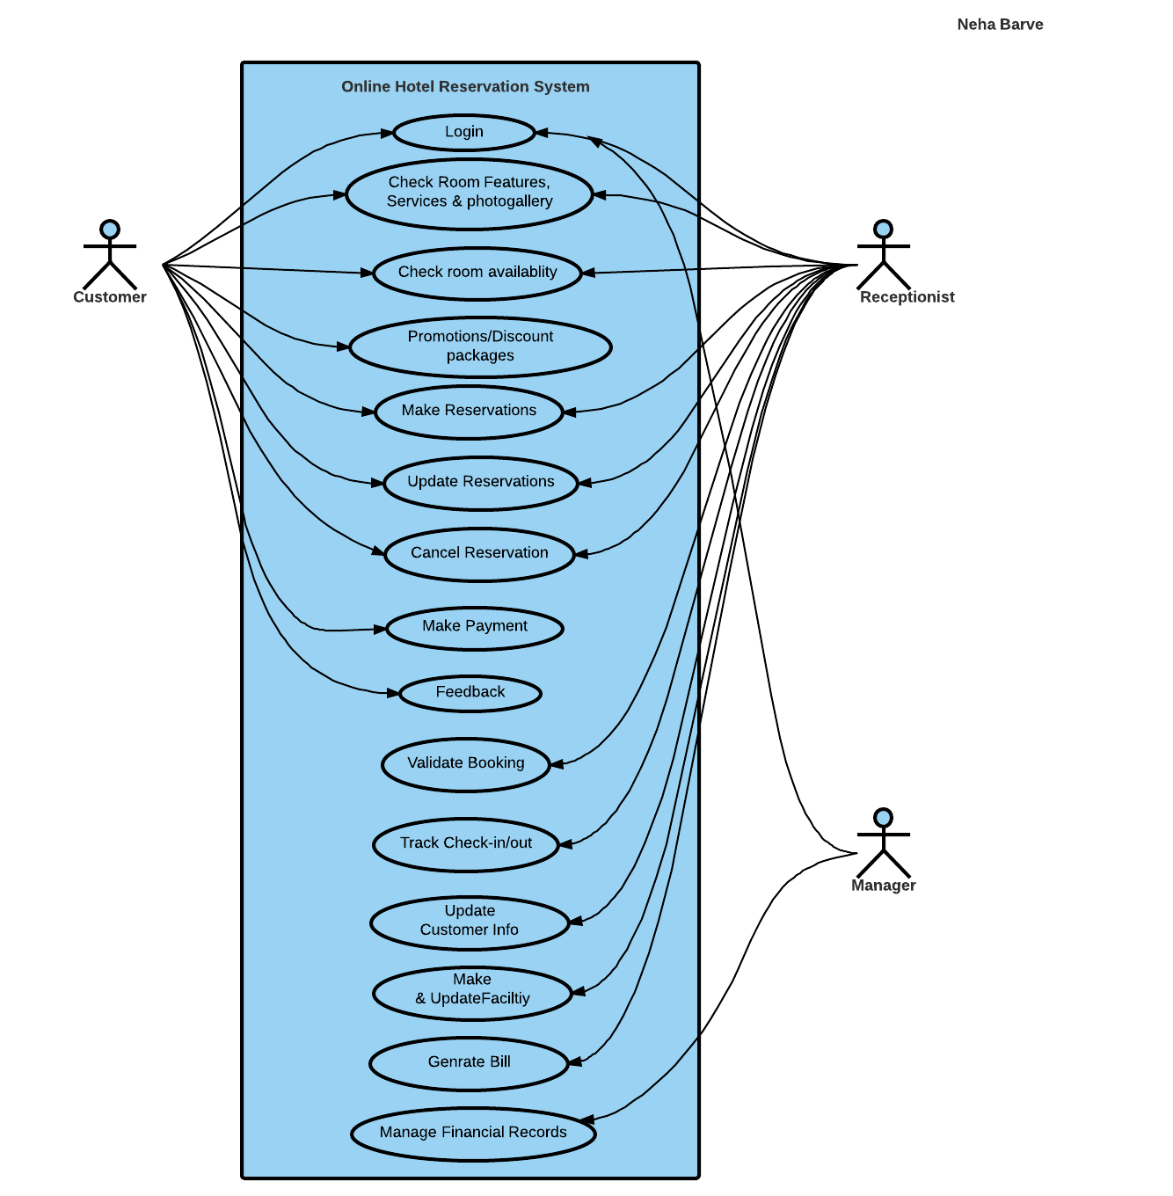

Lucid Chart link for Used-Case Diagram for Hotel Reservation System-

<https://www.lucidchart.com/invitations/accept/b5ae0065-b9d5-4c9a-ae9b-ee4ccb2a40b4>

**5.2 Used Case Description**

1. **Used Case-Login**

|  |  |
| --- | --- |
| Name | Login |
| Actor | Customer/Staff |
| Description | Enter login id and password |
| Successful Output | User can retrieve old bookings and manage his account. |
| Alternative | User is not registered member |
| Precondition | User should be registered to login |

1. **User Case- Check Room Availability**

|  |  |
| --- | --- |
| Name | Check Room Availability |
| Actor | Customer, Receptionist |
| Description | Customer & Receptionist can check weather the required type of room is available or not. |
| Successful Output | If available they can make booking. |
| Alternative | If room not available there can be option to add on waiting list. |
| Precondition | None |

1. **Used Case- Check Room Features, Services and Photo gallery**

|  |  |
| --- | --- |
| Name | Check Room Features and Photo gallery |
| Actor | Customer, Receptionist |
| Description | Can check features and services in room |
| Successful Output | Can select room type as per need and rates |
| Alternative | None |
| Precondition | None |

1. **Used Case-Promotion/Discount Packages**

|  |  |
| --- | --- |
| Name | Promotion/Discount Packages |
| Actor | Customer, Receptionist |
| Description | Can enjoy discounted rates and packages |
| Successful Output | Have to pay less than actual rates |
| Alternative | None |
| Precondition | Requires coupon, promotional code |

1. **Used Case-Make reservation**

|  |  |
| --- | --- |
| Name | Make reservation |
| Actor | Customer, Receptionist |
| Description | Make reservation if available |
| Successful Output | Make reservation |
| Alternative | None |
| Precondition | Customer or admin needs to login |
| Postcondition | Database can be updated |

1. **Used Case-Change or Update Reservations**

|  |  |
| --- | --- |
| Name | Change or Update reservation |
| Actor | Customer, Receptionist |
| Description | Changes or update can be made after reservation. |
| Successful Output | Required update or changes made |
| Alternative | None |
| Precondition | Customer or admin needs to login and there should be reservation. |
| Postconditions | Other rooms availability will be available.  Database can be updated by staff. |

1. **Used Case-Cancel Reservations**

|  |  |
| --- | --- |
| Name | Cancel reservation |
| Actor | Customer, Receptionist |
| Description | Cancellation can be done after reservation is done. |
| Successful Output | Booking will be cancelled. |
| Alternative | Options if making new booking |
| Precondition | User needs to login and reservation. |
| Postcondition | No booking & Database will be updated. |

1. **Used Case-Make Payment**

|  |  |
| --- | --- |
| Name | Payment |
| Actor | Customer |
| Description | Payment methods |
| Successful Output | Customer will receive an invoice  Staff can enter payment details. |
| Alternative | Customer can pay after reaching hotel |
| Precondition | Customer needs to login |
| Postcondition | Booking will be confirmed. |

1. **Used Case-Feedback**

|  |  |
| --- | --- |
| Name | Feedback |
| Actor | Customer |
| Description | Questions related to services and customer experience. |
| Successful Output | Suggested possible changes can be according to feedback |
| Alternative | None |
| Precondition | Customer needs to login |

1. **Used Case-Validate Booking**

|  |  |
| --- | --- |
| Name | Validate Booking |
| Actor | Receptionist |
| Description | Not more than 2 adults in one room. |
| Successful Output | Valid bookings are confirmed. |
| Alternative | Invalid Bookings |
| Precondition | Admin should login to validate. |

1. **Used Case-Track Check-In/Check-Out**

|  |  |
| --- | --- |
| Name | Track Check-In/Check-Out |
| Actor | Receptionist |
| Description | Customers should leave hotel as per their check-out time else they will be charged. |
| Successful Output | Check-in, Check-out time can be tracked |
| Alternative | If customers stay more than check-out time. |
| Precondition | None |

1. **Used Case-Update Customer Information**

|  |  |
| --- | --- |
| Name | Update Customer Information |
| Actor | Receptionist |
| Description | Database system is updated with customer information. |
| Successful Output | Customer information is feed into system |
| Alternative | None |
| Precondition | Customer should have room reservation. |

1. **Used Case-Make and Update Facility**

|  |  |
| --- | --- |
| Name | Make and Update Facility |
| Actor | Receptionist |
| Description | Customer is provided with required facility such as cleaning, breakfast |
| Successful Output | Provided with required facility. |
| Alternative | None |
| Precondition | Customer should have room reservation. |

1. **Used Case-Generate Bill**

|  |  |
| --- | --- |
| Name | Generate Bill |
| Actor | Receptionist |
| Description | Generate bill according to facilities used and number of days of stay. |
| Successful Output | Booking details and generate bill |
| Alternative | None |
| Precondition | Customer should have room reservation. |

1. **Used Case-Manage Financial Records**

|  |  |
| --- | --- |
| Name | Manage Financial Records |
| Actor | Manager |
| Description | Reports can be made according to business. |
| Successful Output | Report generation and profit reports |
| Alternative | None |
| Precondition | None |

**5.2 Normal Flow of Events for Making Reservation-**

|  |  |
| --- | --- |
| Actor | System |
| 1)Customer/Receptionist login. | 2) Accepts valid id/password else rejects. |
| 3)Select room type, Date of arrival and Date of Departure. | 4) Provides information room type available or not and room charges. |
| 5)Apply promotional Code/Coupon. | 6)System provides discounted price. |
| 7) Customer confirms reservation & enter all information related to customer | 8)Generate Reservation No. & Bill. |
| 9) Pay Bill | 10)Generate Receipt. |
|  | 11)Track Check-in Check-out timing. |
| Alternate Flows | |
| 1) Selected Room type not available | 2) Gives Option to add in waiting list.  3) Provides option to select another available room type. |
| 4)User make invalid reservation | 5) System rejects reservation and sends user to start point. |
| 6) User Cancel Reservation | 7)Provides option to make new reservation. |

**5.3 Activity Diagram –**

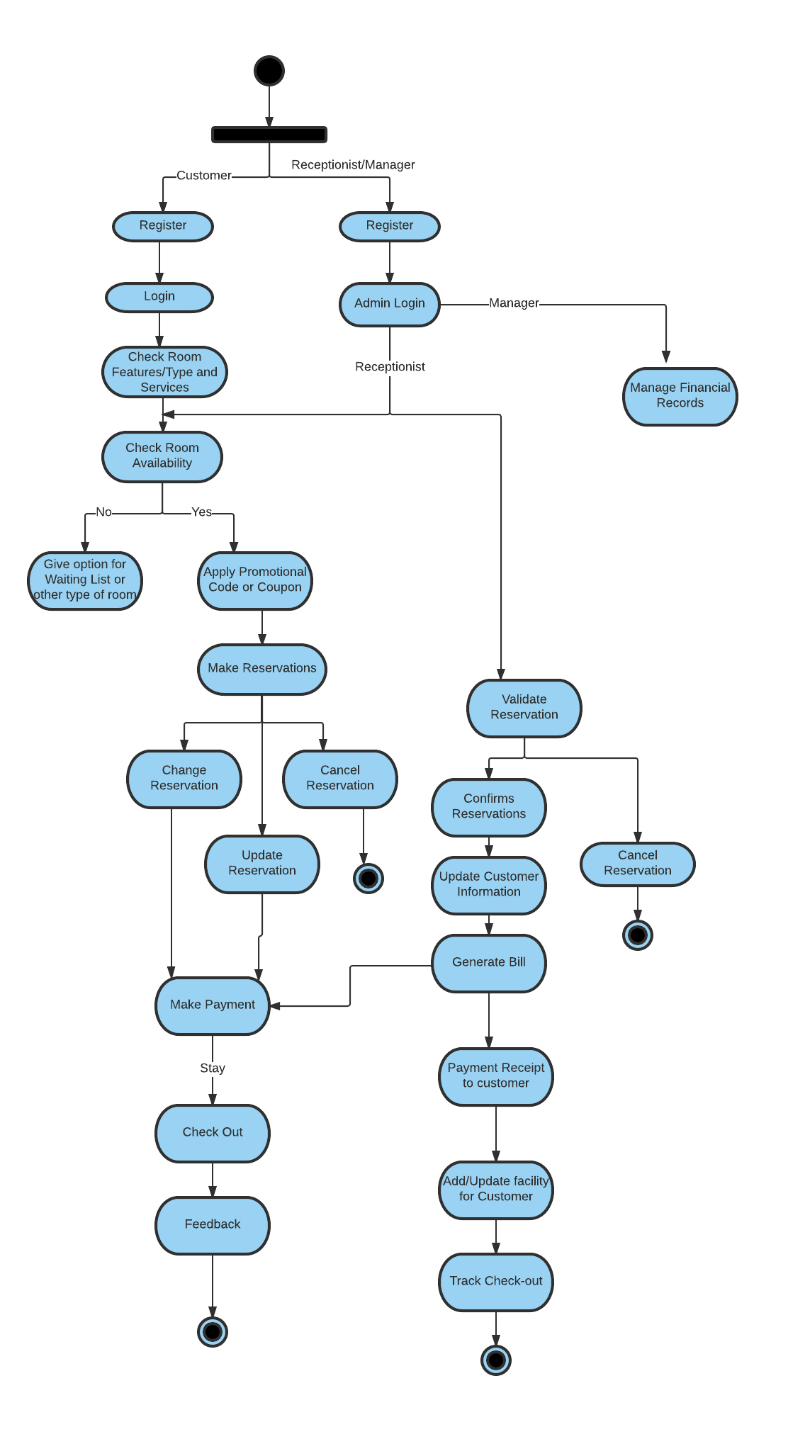

**Link for Activity Diagram –**

<https://www.lucidchart.com/invitations/accept/6f5e2ad9-a9d7-4427-8b75-425386655897>

**5.4 Class Diagram-**

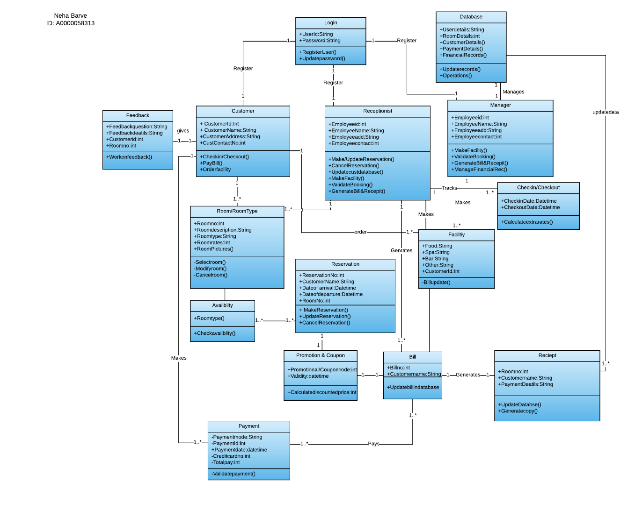

**Multiplicity of Class Diagram-**

1. 1 User can have 1 Login.
2. 1 Customer can give 1 feedback form.
3. 1 Customer/Receptionist can select 1 or more room type.
4. 1 Customer/Receptionist can reserve one or more available room.
5. 1 or more room type can be available and can be reserved.
6. 1 Customer can make 1 or more payment.
7. 1 Coupon/Promotional Code can be used per bill per reservation.
8. 1 Manager can manage one database system.
9. 1 or more facility can be availed by customer and can be arranged by receptionist.
10. 1 receipt is generated for one bill.
11. 1 receptionist can track 1 or more check-in/check-outs.

**Lucid Chart Link for class diagram-**

<https://www.lucidchart.com/invitations/accept/d111e536-2f01-49b6-8342-a217988a7414>

**5.5 Sequence Diagram**

1. **Sequence Diagram for Customer**

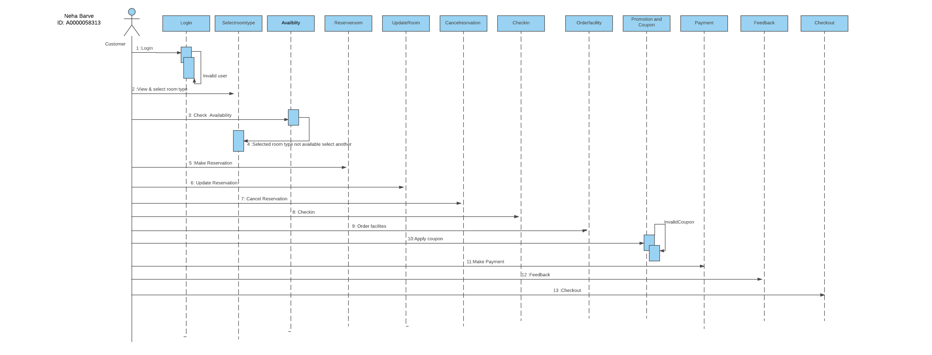

**Lucid chart Link-**

<https://www.lucidchart.com/invitations/accept/d3c2e18f-8b2e-4b03-b856-6945d26dba54>

1. **Sequence Diagram for Receptionist/Manager**

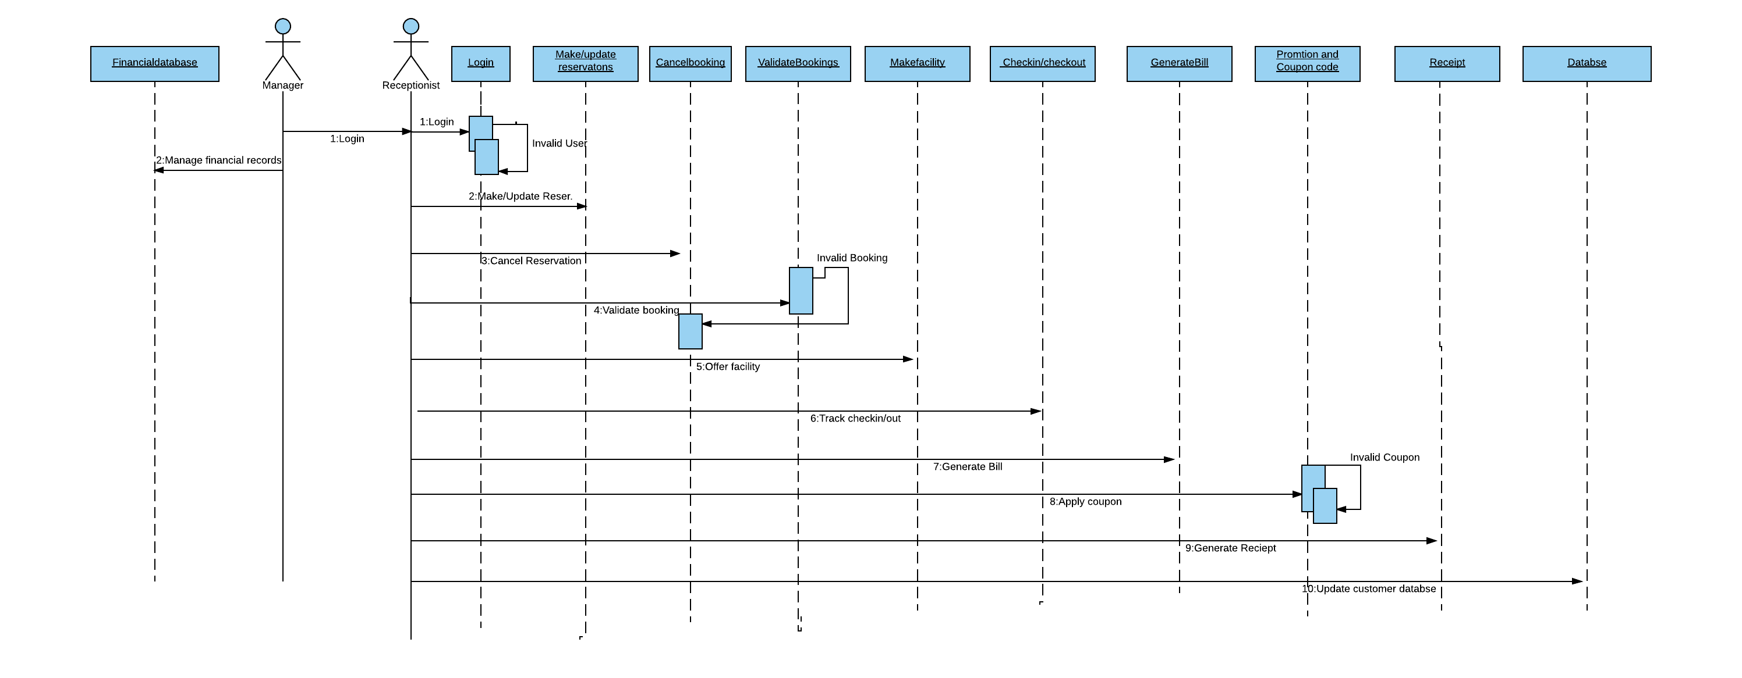

**Lucid chart Link-**

<https://www.lucidchart.com/invitations/accept/16aaab07-408c-4592-adab-c50c5ed0ce22>

**6.Functional Test Plan**

**6.1 Test Case for Hotel Reservation System**-

Testing is important part of building any application or system, in order to check everything is perfectly working as expected and for quality purpose. Whatever functions are requested to the system it is perform them all in proper way.

I had following test cases for Hotel Reservation System-

1. **TC_001-Test the login functionality for hotel reservation.**

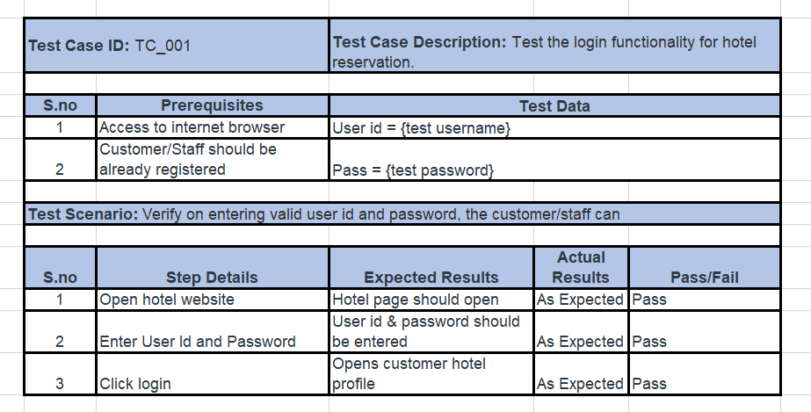

1. **TC_002-Test that user can check availability for selected room type**

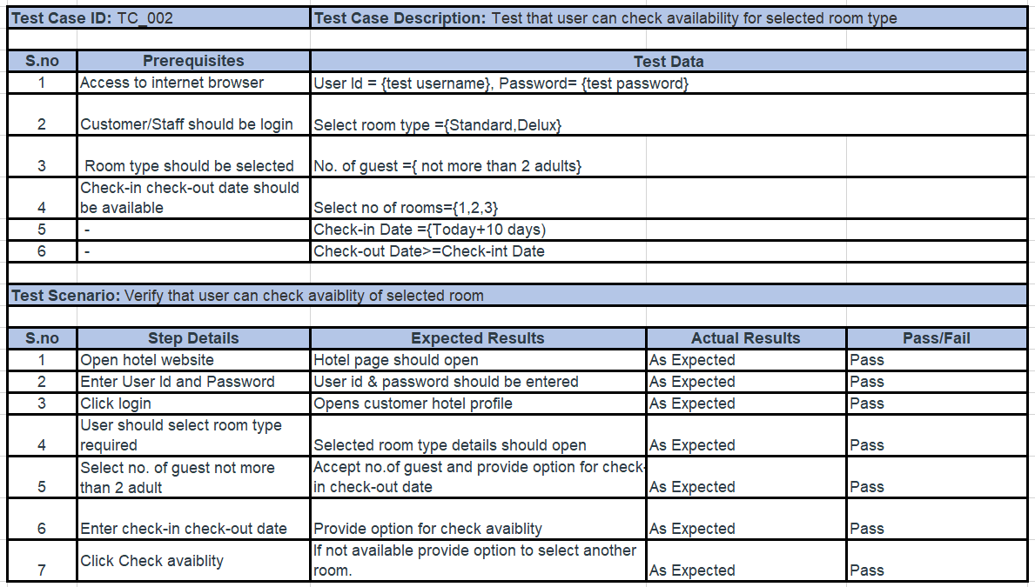

1. **TC_003- Test that user can make valid reservation**

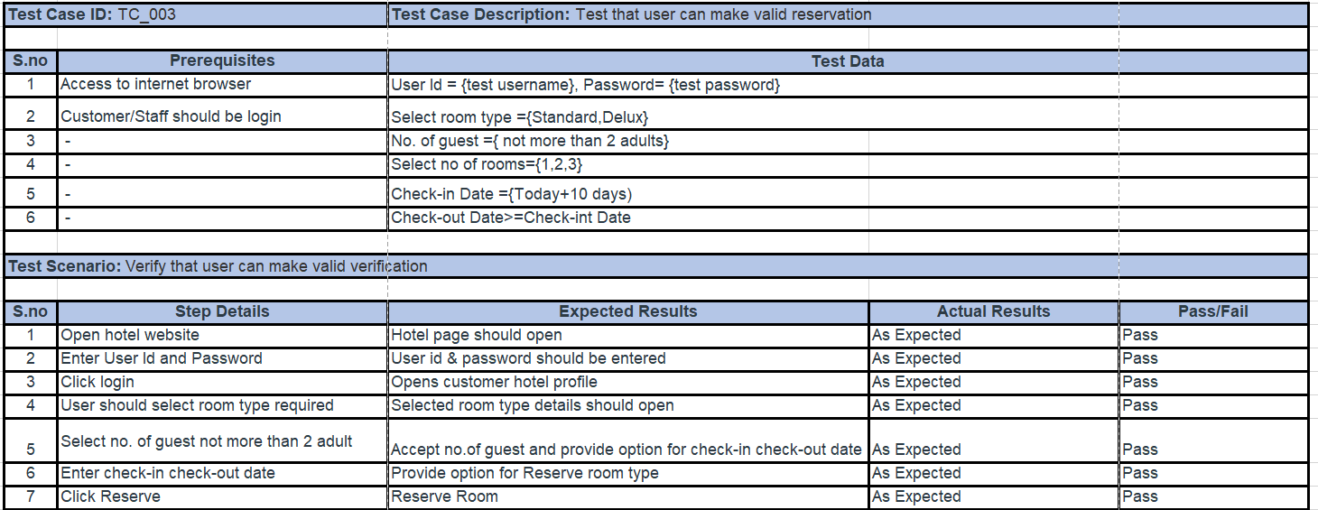

1. **TC_004 - Test that user can update reservation.**

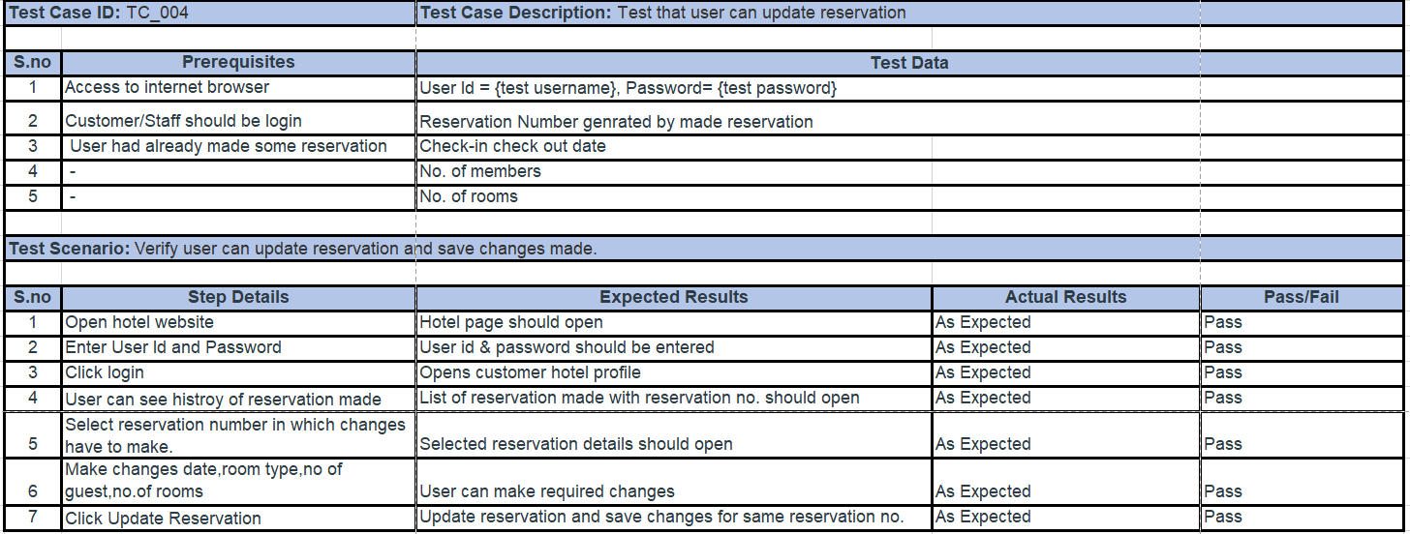

1. **TC_005- Test that user can cancel reservation.**

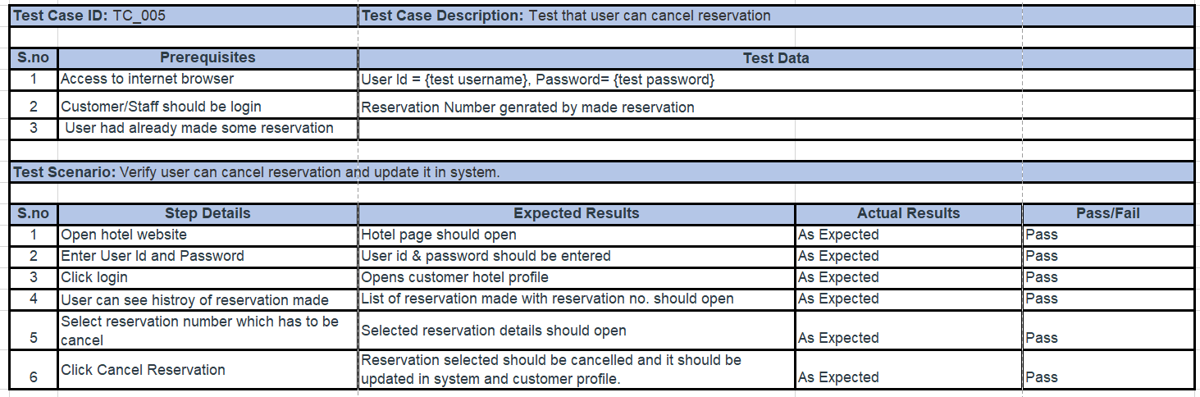

1. **TC_006- Test that receptionist can track check-in & check-out**

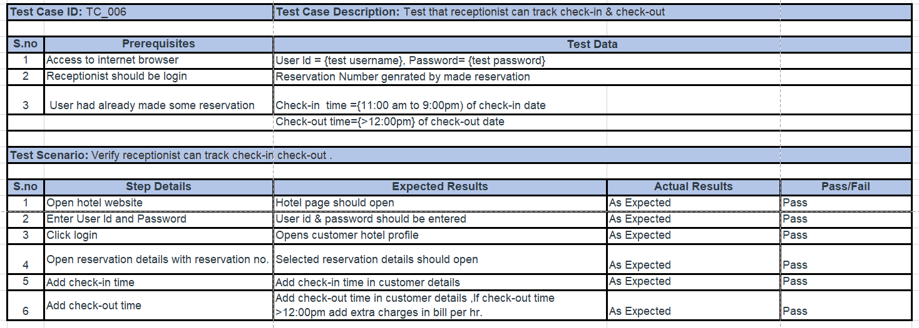

1. **TC_007- Test user can apply promotional/coupon code.**

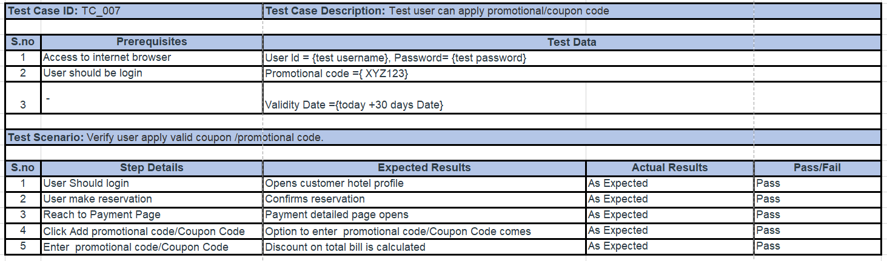

1. **TC_008- Test user can generate bill.**

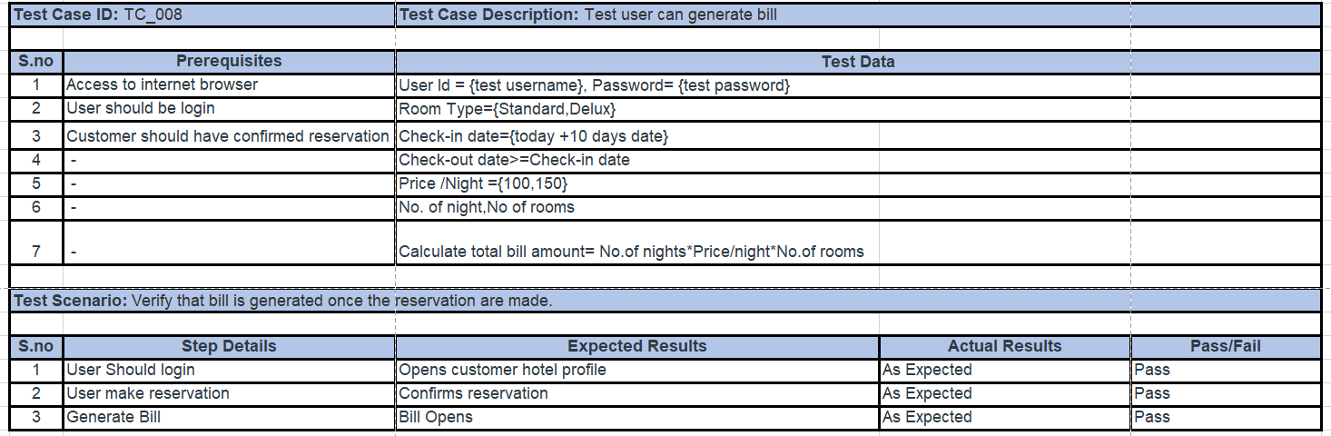

1. **TC_009- Test user can make payment.**

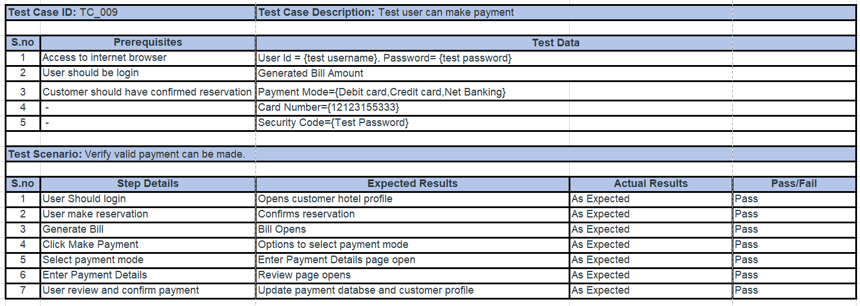

1. **TC_010- Test manager can update financial database.**

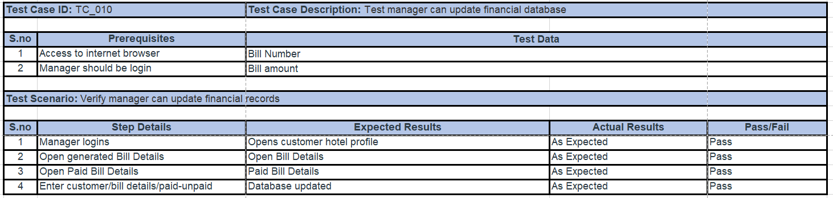

**7**. **User Interfaces**

User interface are the part how system will be looking to the user while different activates such as login, payment, making /updating and cancelling reservation. Following are the user interfaces-

**7.1 Login Page**

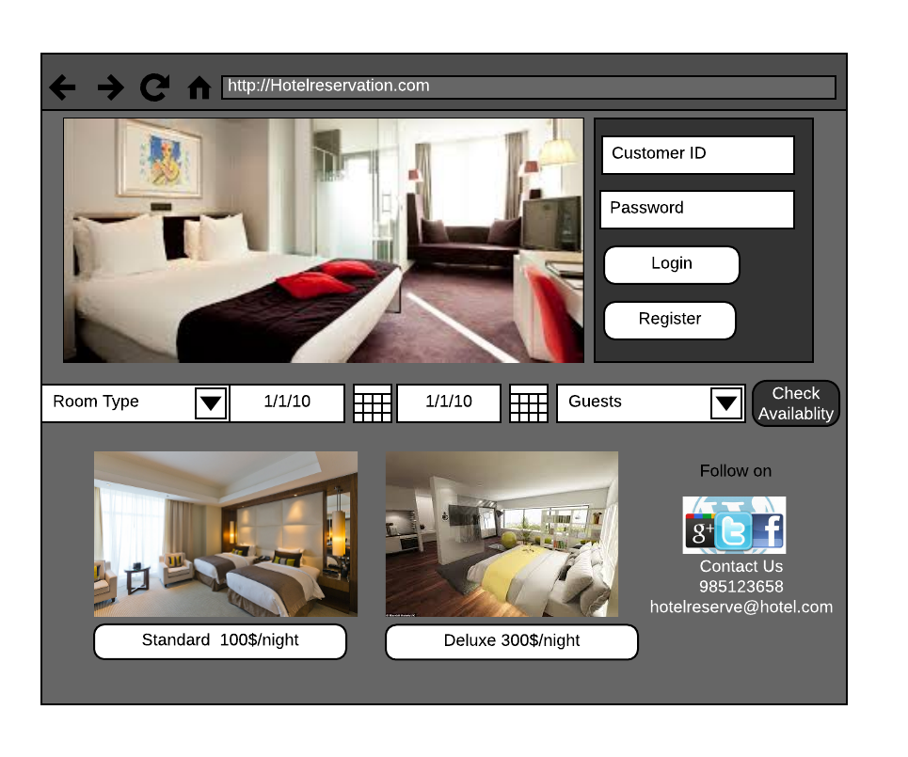

**7.2 Room Features/Gallery**

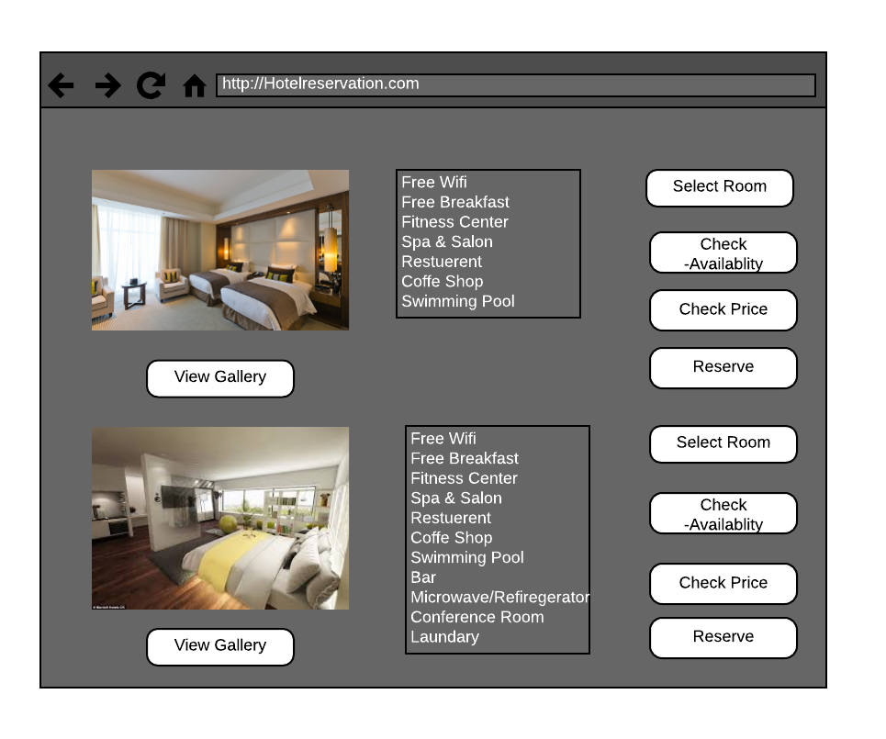

**7.3 Update /Cancel Reservation**

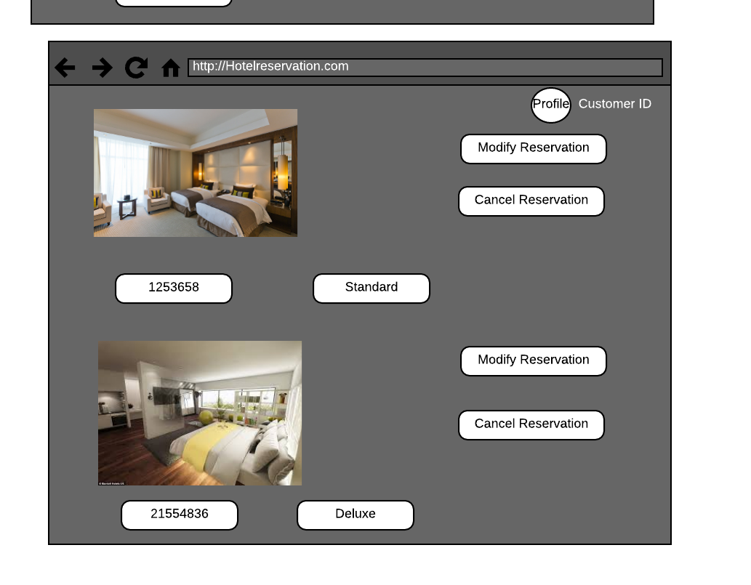

**7.4 Payment Page**

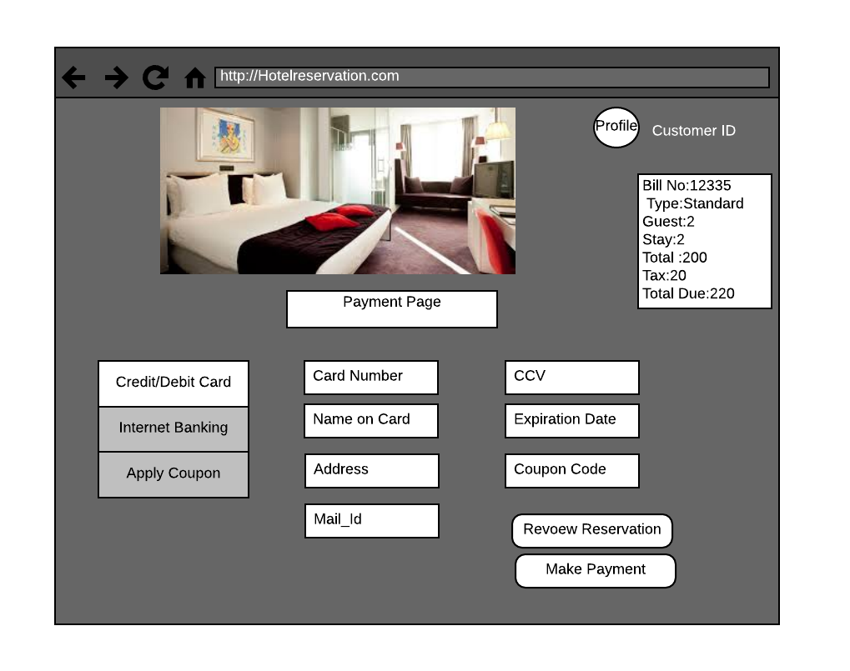

<https://www.lucidchart.com/invitations/accept/45aa0a6a-f2db-46bc-b1f3-dc7f7344d2ad>

**8**. **Implementation**

Implementation system is most important part for the system here is the time for approval and acceptance from the user. For this there are both software and hardware requirements.

**8.1 Software Requirements-**

1. Operating System – Windows(XP,7-10), Mac
2. Web Browser-Chrome, Internet Explorer, Firefox
3. Database Management system- SQL, Oracle
4. Web Development system- Visual Studio
5. Other - .Net Framework

**8.2 Hardware Requirement -**

1. RAM >1GB
2. HDD >=50 GB
3. Processor -Intel
4. LAN connection

**8.3 Deployment Diagram –**

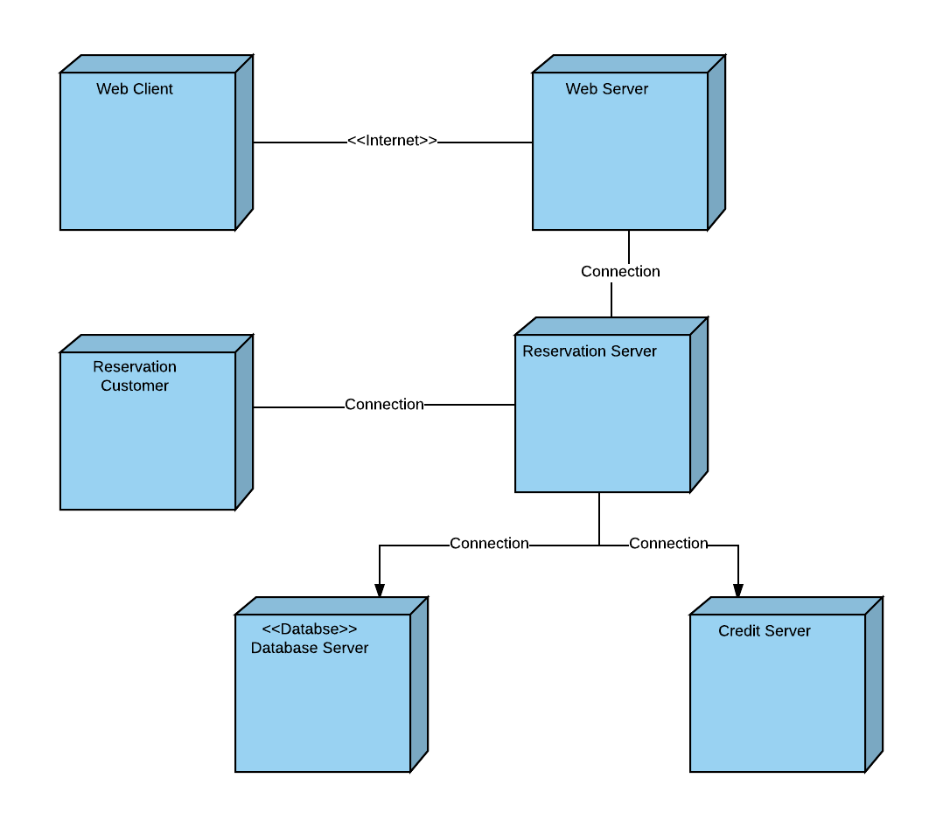

**Lucid Chart Link-**

<https://www.lucidchart.com/invitations/accept/2bff794a-ba0b-4c2e-b1f2-3a0eda8186d9>

**9.Limitations**

System has various advantages over manual reservation system it made the making/ updating/cancelling reservation easy also maintaining records for staff is simple but it has following limitations-

* 1. It does not have chat option or instant respond to customer enquiry.
  2. System does not have third party for payment system such as PayPal.

**10.Conclusion and Lessons Learned**

The system is useful for customers as well as staff. It makes easy for staff for managing records of customers. This system will give user friendly environment for users. There are various challenges which can be faced during implementation, coding and testing of the system which are not part of this project.

From this object-oriented design and analysis project I had learned following concepts-

1. SDLC -System development life cycle.
2. Testing and its types.
3. UML-Unified Module Language.
4. Difference between classes & objects.
5. How business processes are important for designing any system.

**11.References**

<https://www.kayak.com/Boston-Hotels-Sheraton-Boston-Hotel.21792.ksp>

<https://www.google.com/search?q=hotel&source=lnms&tbm=isch&sa=X&ved=0ahUKEwijx93QudLUAhXBwj4KHW9RDU8Q_AUIDCgD&biw=1206&bih=571>

<https://www.scribd.com/doc/117238618/Online-Hotel-Reservation-System>

<https://www.researchgate.net/publication/275097517_DOCUMENTATION_OF_ONLINE_BOOKING_SYSTEM>